Feature Scaling – Standardization

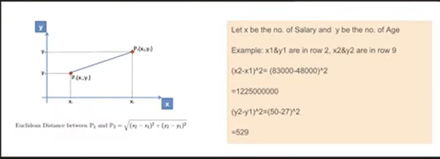

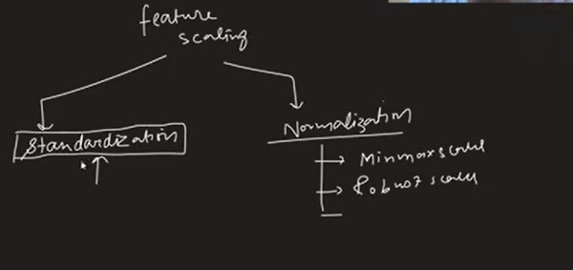

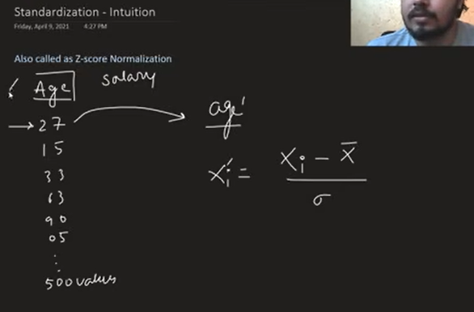

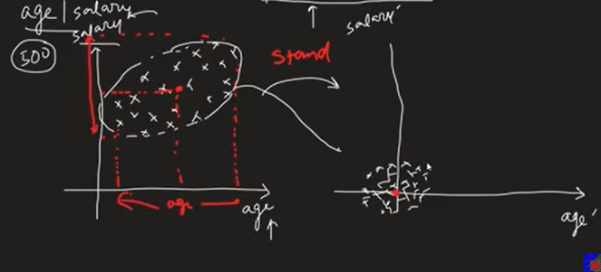

What is Feature Scaling?
Definition:
Feature Scaling is the process of bringing all independent features (input variables) into a similar scale before training a machine learning model.
Example:
Feature | Original Range
Age | 18–60
Salary | 15,000–150,000
After scaling, both features lie on a comparable scale.

Why Do We Need Feature Scaling?
Many Machine Learning algorithms calculate distance between data points.
Example:
- K-Nearest Neighbors (KNN)
- K-Means Clustering
- Support Vector Machine (SVM)
If one feature has much larger values than another, it dominates the distance calculation.
Example:
Age = 20
Salary = 80,000
Since salary values are much larger, salary contributes more to the distance than age, causing poor model performance.
Feature scaling ensures every feature contributes fairly.

Types of Feature Scaling
There are two major techniques:

1. Standardization (Z-score Normalization)
(Covered in this lecture)

2. Normalization (Min-Max Scaling)
(Covered in the next lecture)

Standardization
Standardization transforms data so that:
- Mean = 0
- Standard Deviation = 1
It is also called Z-score Normalization.

Standardization Formula
Where:
- x = Original value
- μ = Mean of the feature
- σ = Standard deviation
- z = Standardized value

Example
Suppose:
Age values
20, 25, 30, 35, 40
Mean = 30
Standard deviation = 5
For Age = 25
[
z=\frac{25-30}{5}=-1
]
Every value is converted using the same formula.

Properties of Standardized Data
After standardization:
- Mean = 0
- Standard deviation = 1
- Distribution shape remains the same
- Only the scale changes

Geometric Intuition
Standardization performs two operations:

1. Mean Centering
Moves the data so that its center becomes zero.
Before:
Mean = 35
After:
Mean = 0

2. Scaling
Changes the spread of data so that:
Standard Deviation = 1
The dataset becomes centered and uniformly scaled.

Standardization in Scikit-learn
from sklearn.preprocessing import StandardScaler

scaler = StandardScaler()

scaler.fit(X_train)

X_train_scaled = scaler.transform(X_train)

X_test_scaled = scaler.transform(X_test)

Why Fit Only on Training Data?
Correct workflow:
- Split into Train/Test.
- Fit scaler on training data only.
- Transform training data.
- Transform test data using the same scaler.
Never fit on the test set, because it causes data leakage.

Before vs After Standardization
Before:
- Mean ≠ 0
- Standard deviation ≠ 1
After:
- Mean = 0
- Standard deviation = 1

Effect on Data Distribution
Standardization does not change:
- Shape of distribution
- Relative ordering of samples
- Pattern of the data
It only changes:
- Scale
- Mean
- Standard deviation

Effect on Model Performance
Example:

Logistic Regression
Without scaling
Accuracy ≈ 65%
With standardization
Accuracy ≈ 86%
Reason:
Logistic Regression uses Gradient Descent, which converges faster when features are on similar scales.

Decision Tree
Accuracy remains almost unchanged.
Reason:
Decision Trees compare feature values rather than computing distances, so scaling has little effect.

Effect of Outliers
Standardization does not remove outliers.
Outliers remain outliers after scaling.
Therefore:
- Handle outliers before applying Standardization if necessary.

Algorithms That Require Standardization
Always standardize before using:
- K-Nearest Neighbors (KNN)
- K-Means Clustering
- Support Vector Machine (SVM)
- Principal Component Analysis (PCA)
- Logistic Regression
- Linear Regression (Gradient Descent implementation)
- Neural Networks / Deep Learning
- Gradient Descent–based algorithms

Algorithms That Usually Do NOT Need Standardization
Scaling is generally unnecessary for:
- Decision Trees
- Random Forest
- XGBoost
- LightGBM
- CatBoost
These algorithms split data based on thresholds rather than distances.

Best Practice
Correct pipeline:
- Train-Test Split
- Handle Missing Values
- Encode Categorical Variables
- Handle Outliers (if needed)
- Standardize Features
- Train Machine Learning Model

Key Takeaways
- Feature Scaling brings all input features to a similar scale.
- Standardization transforms data to have mean = 0 and standard deviation = 1.
- Formula:
[
z=\frac{x-\mu}{\sigma}
]
- Always fit the scaler on the training set only.
- Standardization improves performance for distance-based and gradient-based algorithms.
- It does not change the shape of the data distribution.
- It does not remove outliers.
- Tree-based algorithms usually do not require feature scaling.

